Lab # 7
java string class

OBJECTive

To Study Java String class and Java String Buffer.

THEORY
Strings, which are widely used in Java programming, are a sequence of characters. In the Java programming language, strings are objects.
The Java platform provides the String class to create and manipulate strings.

Creating Strings:
The most direct way to create a string is to write:
String greeting = "Hello world!";
Whenever it encounters a string literal in your code, the compiler creates a String object with its value in this case, "Hello world!'.
As with any other object, you can create String objects by using the new keyword and a constructor. The String class has eleven constructors that allow you to provide the initial value of the string using different sources, such as an array of characters:
public class StringDemo{

public static void main(String args[]){
char[] helloArray = { 'h', 'e', 'l', 'l', 'o', '.'};
String helloString = new String(helloArray);
System.out.println( helloString );
}
}
This would produce following result:
hello.

Note: The String class is immutable, so that once it is created a String object cannot be changed. If there is a necessity to make alot of modifications to Strings of characters then you should use String Buffer & String Builder Classes.

String Methods:
Here are the list methods supported by String class:

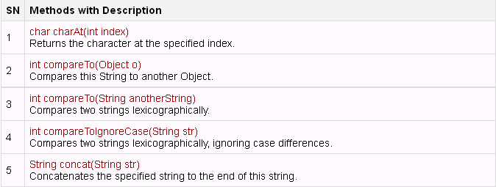

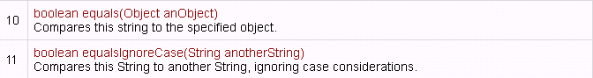

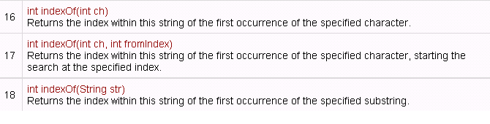

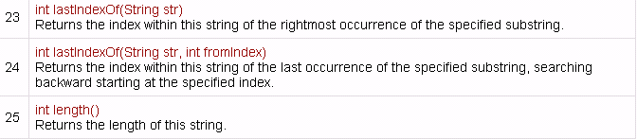

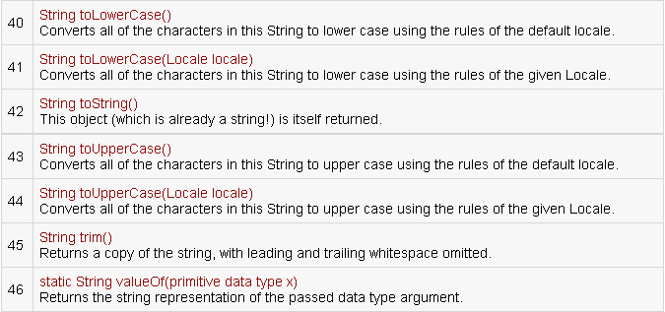

Program#1
This program uses different string classes.

public class StringClass{
public static void main (String[] args){

String s1 = new String("ABC");
String s2 = new String("ABC");
String s3 ="ABC";
String s4 ="ABC";
String s5 = new String("abc");

System.out.println("\t\t\ts1="+s1);
System.out.println("\t\t\ts2="+s2);
System.out.println("\t\t\ts3="+s3);
System.out.println("\t\t\ts4="+s4);
System.out.println("\t\t\ts5="+s5);

System.out.println("\n** == **");
System.out.println("\ns1==s2 -> "+(s1==s2));
System.out.println("s1==s3 -> "+(s1==s3));
System.out.println("s3==s4 -> "+(s3==s4));

//Equals
System.out.println("\n**Equals**");
System.out.println("s1.equals(s2) -> "+s1.equals(s2));
System.out.println("s1.equals(s5) -> "+s1.equals(s5));
System.out.println("XYZ".equals("XYZ"));

//Equals Ignore Case
System.out.println("\n**Equals Ignore Case**");
System.out.println(s1.equalsIgnoreCase(s5));
System.out.println("XYZ".equalsIgnoreCase("xyz"));

//Starts With
System.out.println("\n**Starts With**");
System.out.println(s1.startsWith("A"));

//Ends With
System.out.println("\n**Ends With**");
System.out.println(s1.endsWith("C"));
System.out.println("SSUET Karachi".endsWith("i"));

//Compare To
System.out.println("\n**Compare To**");
System.out.println(s1.compareTo(s2));

//Character At
System.out.println("\n**Character At**");
System.out.println(s1.charAt(0));

//Length
System.out.println("\n**Length**");
System.out.println(s1.length());

//To Lower Case
System.out.println("\n**To Lower Case**");
System.out.println(s1.toLowerCase());

//Index Of
System.out.println("\n**Index Of**");
System.out.println(s1.indexOf('A'));

//last Index Of
System.out.println("\n**last Index Of**");
System.out.println(s1.lastIndexOf('A'));

//Sub String
System.out.println("\n**Sub String**");
System.out.println(s1.substring(1,2));

//Replace
System.out.println("\n**Replace**");
System.out.println(s1.replace('A','Z'));

}
}

Output:
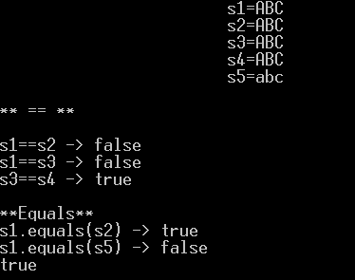

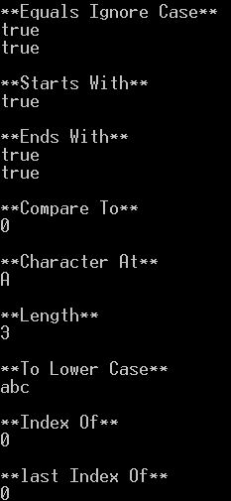
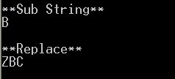

String Buffer
StringBuffer is a peer class of String that provides much of the functionality of strings. As you know, String represents fixed-length, immutable character sequences. In contrast, StringBuffer represents growable and writeable character sequences. StringBuffer may have characters and substrings inserted in the middle or appended to the end. StringBuffer will automatically grow to make room for such additions and often has more characters pre allocated than are actually needed, to allow room for growth.

StringBuffer Constructors
StringBuffer defines these three constructors:

StringBuffer( )
StringBuffer(int size)
StringBuffer(String str)
The default constructor (the one with no parameters) reserves room for 16 characters without reallocation. The second version accepts an integer argument that explicitly sets the size of the buffer. The third version accepts a String argument that sets the initial contents of the StringBuffer object and reserves room for 16 more characters without reallocation. StringBuffer allocates room for 16 additional characters when no specific buffer length is requested, because reallocation is a costly process in terms of time. Also, frequent reallocations can fragment memory. By allocating room for a few extra characters, StringBuffer reduces the number of reallocations that take place.

Program#2
Creating String Buffer Objects. length, capacity, ensureCapacity, setLength, append, insert, charAt, setChatAt and toString Functions.

public class str{
public static void main (String[] args){

StringBuffer s1 = new StringBuffer("ABC");
StringBuffer s2 = new StringBuffer();
StringBuffer s3 = new StringBuffer(50); // Capacity 50

System.out.println("s1= "+s1); //Print data
System.out.println("s1.length() = "+s1.length()); //Print length = 3
System.out.println("s1.capacity() = "+s1.capacity()); //print capacity. Default 16 + 3 = 19
System.out.println("s2.length() = "+s2.length()); //print length = 0
System.out.println("s1.capacity() = "+s2.capacity()); //print default capacity 16
System.out.println("s3.length() = "+s3.capacity()); //Print 50

//Append
System.out.println("**\nAppend**");
System.out.println("Capacity of S2 = "+s2.capacity()); //Capacity remain 16
System.out.println("Length of S2 = "+s2.length());
s2.append("ABCDEF");
System.out.println(s2);
System.out.println("Capacity of S2 = "+s2.capacity()); //Capacity remain 16
System.out.println("Length of S2 = "+s2.length());
s2.append("GHIJKLMNOP");
System.out.println("Capacity of S2 = "+s2.capacity()); //Capacity remain 16
System.out.println("Length of S2 = "+s2.length());
s2.append("Q");
System.out.println("Capacity of S2 = "+s2.capacity()); //Capacity 34 after length 16+
System.out.println("Length of S2 = "+s2.length());

//Character At
System.out.println("\n**Character At**");
System.out.println(s1.charAt(0));

//Set Character At
System.out.println("\n**Set Character At**");
System.out.println(s1); //Original Value
s1.setCharAt(0,'X');
System.out.println(s1); //After Change

//To String
System.out.println("\n**To String**");
System.out.println(s1); //Original Value in String Buffer
String s = s1.toString();
System.out.println(s); // Convert from String Buffer to String
}
}

Output:

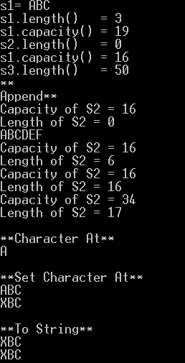

LAB TASK

- Write a program that extracts username and the domain information from an E-mail address. For example, if the email address is "user@mydomain.com", your program will print
User name = user
Domain = mydomain
Extension = com

- A PALINDROME is a word which has SAME SPELLING whether it is read from Left to Right or from Right to Left. Example: MOM, DAD, DEED, PEEP and NOON. Other words which are not PALINDROME are HELLO, DOOR and FEET. Write a program that can take a String as user input in Capital Letters and then Print YES as Output if the Input is a PALINDROME otherwise NO.

- Write a program in to print individual characters of string in reverse order.

- Write a program in to count total number of vowel or consonant in a string.

- Write a program to check whether a given substring is present in the given string.
- Write a program to read a sentence and replace lowercase characters by uppercase and vice-versa.
Test Data :
Input the string : This Is A Test String.
Expected Output :
The given sentence is : This Is A Test String.
After Case changed the string is: tHIS iS a tEST sTRING.

- Write a program to Find the Frequency of Characters.
Test Data :
Input the string : This is a test string
Input the character to find frequency: i
Expected Output :
The frequency of 'i' is : 3

